**KWAME NKRUMAH UNIVERSITY OF SCIENCE AND TECHNOLOGY**



COLLEGE OF ENGINEERING

DEPARTMENT OF MECHANICAL ENGINEERING

ME 396 MECHANICAL ENGINEERING LABORATORY IV

BIFILAR SUSPENSION

GROUP A

DATE: 19th March, 2019

**GROUP MEMBERS**

|  |  |
| --- | --- |
| **NAME** | **INDEX NUMBER** |
| Atomboh, Vincent Essuman | 5971016 |
| Nyamekye, Joel Kwaku | 5978816 |
| Ansah, Emmanuel Abban | 5969216 |
| Krampah, Emmanuel | 5976816 |
| Eshun, Emmanuel | 5974716 |
| Attoh, Derrick | 5982816 |
| Kotei, Shane Nii Amon | 5976716 |
| Yadah, Gareth Koranteng | 2289414 |
| Amoateng – Mensah, David | 5968816 |
| Afful, Joseph Kabenla Animnyam | 5967216 |
| Otchere, Shadrack Appiah | 5980816 |
| Boye, Samuel | 5972816 |

**AIMS AND OBJECTIVES OF THE EXPERIMENT**

1. To investigate how the period of oscillation varies with the distance, d, between the vertical suspension threads.
2. To investigate how the period of oscillation varies with the length l of the suspension threads.
3. To determine the moment of inertia of the connecting rod used during the experiment

**INTRODUCTION**

The bifilar suspension is a technique used to determine the moment of inertia of any type of object about any point on the object. This is done by suspending two parallel cords of equal length through the object examined. However, the approach taken for this experiment is to determine the moment of inertia of a drop by suspending the cords through the mass Centre of bodies, obtaining an angular displacement about the vertical axis through the Centre of mass by a sensibly small angle.

**SYSTEM LAYOUT AND APPARATUS**

           The apparatus used for this experiment consists of a connecting rod of mass 176g suspended by fine wires (assumed to have negligible weight contribution to the system). The wires are wound round a horizontal bar which enables the user to alter length of suspended wires.

Other apparatus include;

1. Stopwatch
2. Tape measure

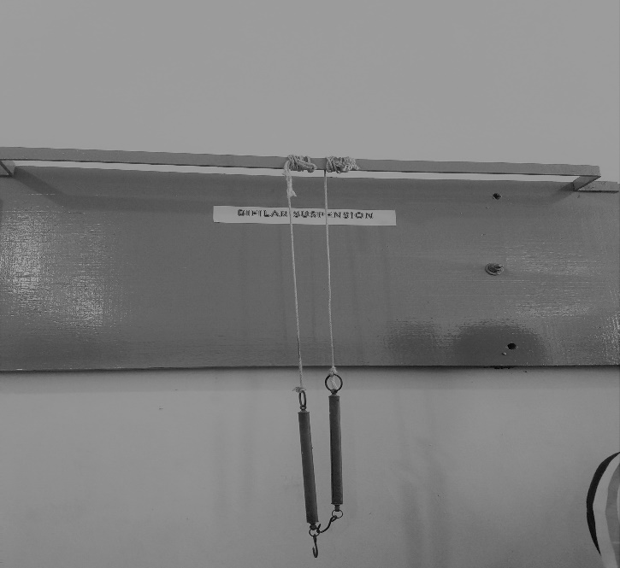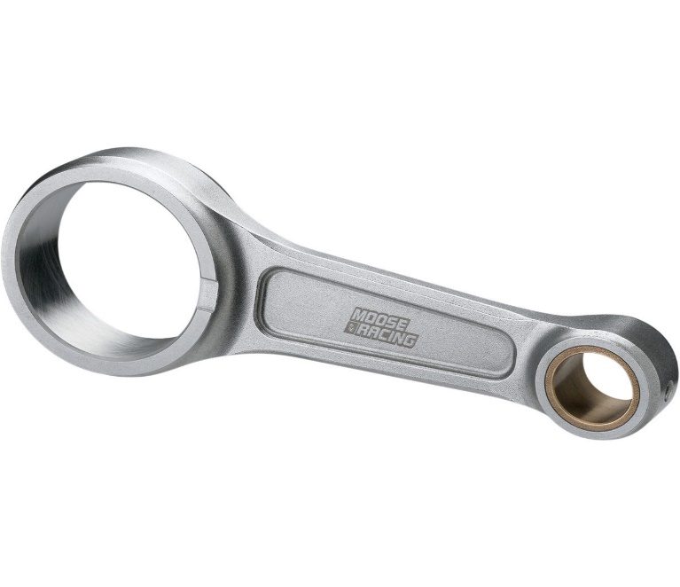

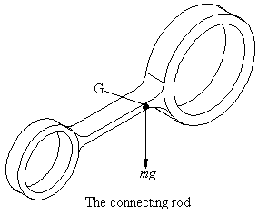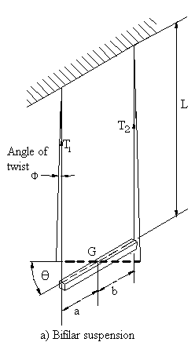

For small angular displacement of the system about a central vertical axis, considering the left wire we have;





Component of T1 perpendicular to rod 

For small angles,  

Restoring couple due to T1 on this wire,  

Restoring couple on the other wire, 

Total restoring couple = +  

But Torque, T



Also =  for Simple Harmonic Motion









**PROCEDURE**

1.       With the bar suspended by the wires, the length ***L*** was adjusted to a convenient extent and then distance, ***b***, between the wires was measured.

2.       The bar was then tilted through a very small angle about the vertical axis and time taken for 20 oscillations of the bar, was recorded. From this, the periodic time was also calculated.

3.       The length ***L*** was further adjusted and the time taken for another 20 oscillations was recorded.

4.       Process 2 and 4 are repeated for 5times

B=13cm a=10.3cm mass of connecting rod is 176g

Total length of connecting rod is 23.3cm

**RESULTS**

|  |  |  |  |  |  |
| --- | --- | --- | --- | --- | --- |
| LENGTH(CM) | TIME(sec) | T2 | T3 | Tavg | T2 |
| 44 | 29.6 | 29.4 | 29.3 | 29.43 | 866.32 |
| 51 | 31.9 | 31.7 | 32.9 | 32.16 | 1034.69 |
| 58 | 32.4 | 33.8 | 34.8 | 33.66 | 1133.44 |
| 65 | 33.5 | 33.2 | 32.7 | 33.13 | 1097.81 |
| 72 | 32.8 | 33.6 | 34.0 | 33.46 | 1120.01 |

**CALCULATIONS**

From 



where grad is the gradient of the graph of against L.

g = 9.81

grad = 3.218

$k=\sqrt{\frac{\left(3.218×0.103×0.13×9.81\right)}{4π^{2}}}$

$k=0.1034m$

The moment of inertia, I, of the rod about the centre of gravity is given by, $I=m×k^{2}$

Where m= mass of connecting rod

K= radius of gyration.

$I=0.176×{\left(0.1034\right)}^{2}$

$I=0.00188kgm^{2}$

**OBSERVATION**

1.       The periodic time significantly increased when the length of the wires also go increased.

2.       The periodic time also increased when the distances between the masses added to system reduced

**PRECAUTIONS**

1. Small angular displacement was given to the system about the vertical axis.
2. Timing was taken for large number of swings and an average value for the period recorded to minimize errors.
3. The connecting rod was positioned on the suspension table for its center of mass to coincide with that of the table for the tension in the wires to be fairly equal.